**Technical Documentation**

**Problem Description**:

In this problem statement we are given different kinds of images of cars. We have to detect the car parts using the YOLOv3 (You Only Look Once Version 3) computer vision algorithm. We have to detect the Five parts of the car. They are 1) Light (Front and Back Light), 2) Glass (Front and Back Glass), 3) Side Glass, 4) Door and 5) Wheel.

**Database Information**:

1. Initially the car image dataset was taken from this link

(<https://github.com/bhadreshpsavani/CarPartsDetectionChallenge/tree/master/Data/Source_Images>) which had 101 training images of cars and 10 test images of cars.

1. Later, we captured 2 new car images from Google and used it for training and testing purpose.
2. In the last step, we captured 10 new car images from the Google and used it only for testing purpose without training the model. This image data is called as Unseen data.

**Prerequisites**:

The tools required to work on this project are Visual Object Tagging Tool (VoTT) Annotation Tool powered by Microsoft, Google Colaboratory for training Yolov3 model and running the car parts detection, Tensorflow version =1.15.2, Keras version = 2.2.4. The other python packages which are required are mentioned in requirements.txt. (<https://github.com/bhadreshpsavani/CarPartsDetectionChallenge/blob/master/requirements.txt>)

Clone the GitHub repository <https://github.com/bhadreshpsavani/CarPartsDetectionChallenge/> inside the local system and upload it to the Google Drive.

**Model Designed**:

YOLO is You Only Look Once. It is state-of-the-art real-time object detection system. It is extremely fast and accurate.

Working: Before detection, it repurposes classifiers and localizers to perform detection. It applies the model to an image at multiple locations and scales. A single neural network is applied to the whole image. This network divides the image into regions and predicts the bounding boxes and probabilities for each region. The bounding box prediction is done by predicted probabilities.

Pros: 1. It takes the whole image during the test time so that its predictions are informed by global context in the image.

2. It makes the prediction with a single network evaluation.

3. It is fast, more than 1000 times faster than R-CNN and 100 times faster than Fast R-CNN.

YOLO Version 3 is much faster and more accurate than YOLO.

**Method**:

1. Image Annotation:

In this step, we install the Visual Object Tagging Tool (VoTT) of Microsoft for performing annotation of different car images. We perform the image annotation by taking the training examples from **CarPartsDetectionChallenge-master/Data/Source_Images/ Training_Images/** directory. Press Ctrl+E to export the project. It creates a new folder **vott-csv-export** in the same directory and it contains file **Annotations-export.csv** contains file names and bounding box coordinates like $X_{min}$, $X_{max}$, $Y_{min}$, $Y_{max}$ and kind of labels used to annotate the car parts.

Results are stored in the json format inside **CarPartsDetectionChallenge-master/ Data/Source_Images/Training_Images/** directory. The last step is to run the code **Convert_to_YOLO_format.py** present inside the directory **CarPartsDetectionChallenge-master/ 1_Image_Annotation.**

It generates two output files: 1) data_train.txt -which stores the pixel values of the image used for annotation. It is present in the directory **CarPartsDetectionChallenge-master/Data/Source_Images/ Training_Images/**, 2) data_classes.txt which has the kind of labels used for labelling. It is present in **CarPartsDetectionChallenge-master/Data/Model_Weights**

**Note:** Steps 2 and 3 are to be run inside Google Colaboratory platform. Upload the entire **CarPartsDetectionChallenge-master/** folder inside the Google Drive

1. Training the model using YOLOv3:

In this step, download the pre-trained weights. Train your own YOLO model on the annotated images.

Mount your Google Drive as follows:

**from google.colab import drive**

**drive.mount('/content/drive’)**

Set up the repository and Google Colab, test the settings

Run the following codes

1. **Minimal_Example.py** – Go to the directory **/content/drive/MyDrive/CarPartsDetectionChallenge-master/** path in the Google Drive to run the file. The outputs are saved in **/content/drive/MyDrive/CarPartsDetectionChallenge-master/Data/Source_Images/Test_Image_Detection_Results**. It includes car pictures with bounding boxes around faces with confidence scores and Detection_Results.csv file with file names and locations of bounding boxes.
2. **Convert_to_YOLO_format.py** - Go to the directory **/content/drive/MyDrive/CarPartsDetectionChallenge-master/1_Image_Annotation/** path in the Google Drive to run the file. It prepares the dataset for training YOLO model

Go to directory **/content/drive/MyDrive/CarPartsDetectionChallenge-master/2_Training/** in the Google Drive to run the below mentioned files

1. **Download_and_Convert_YOLO_weights.py** – It downloads the pre-trained yolov3 weights and convert them to the keras format.
2. **Train_YOLO.py** – It runs the YOLOv3 model with the help of keras and tensorflow packages and creates YOLOv3 model with 9 anchors (anchor boxes) and 5 classes. Training is done on 91 samples, validation is done on 10 samples with batch size 32. The final weights are saved in **/content/drive/MyDrive/CarPartsDetectionChallenge-master/Data/Model_weights**.

Run the Tensorboard to see the results using the commands:

**%load_ext tensorboard**

**%tensorboard --logdir Data/Model_Weights**

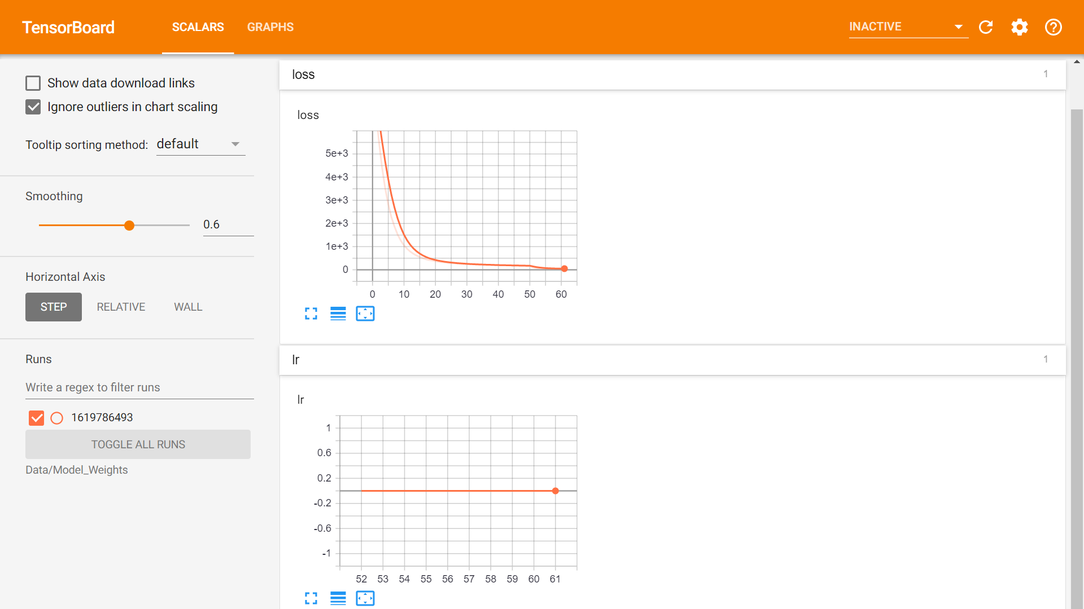

Fig 1: Results inside the Tensorboard for Model Weights

1. Run the Inference:

In this step, we perform object detection on the new images. It displays the name of the part on the bounding box and IOU (Intersection over union) score of area covered by the bounding box for that particular part. If IOU score >0.5, it is good prediction

In order to apply Intersection over Union to evaluate an object detector we need:

1. The ground-truth bounding boxes (i.e., the hand labeled bounding boxes from the testing set that specify where in the image our object is).
2. The predicted bounding boxes from our model.

IOU=Area of Overlap/Area of Union

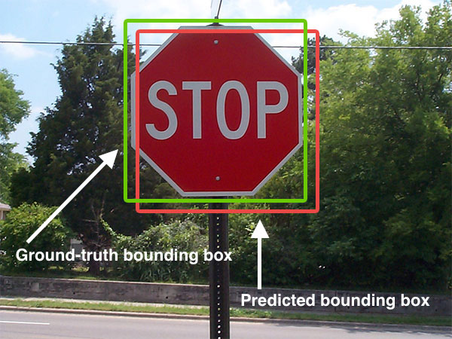

Fig 2: The predicted bounding box is in red colour and the ground-truth bounding box is in green colour

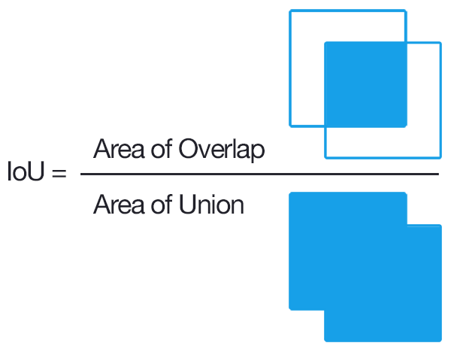

Fig 3: Formula for IOU

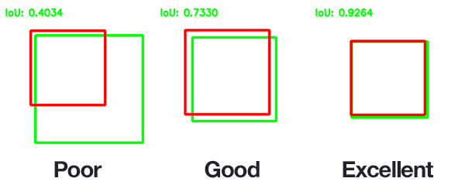

Fig 4: Different kinds of IOU

Implementation: Go to directory **/content/drive/MyDrive/CarPartsDetectionChallenge-master/** to run Minimal_Example.py. The results are same as in step 2.

Go to directory **/content/drive/MyDrive/CarPartsDetectionChallenge-master/3_Inference/** path to run file Detector.py. This program tests the trained model on the new images and results are stored in **/content/drive/MyDrive/CarPartsDetectionChallenge-master/Data/Source_Images/Test_Image_Detection_Results/** in the Google Drive.

**Trials:**

The project was performed in three phases. They were

1. **Phase 1**: In this phase, the model was trained using the car image dataset from

<https://github.com/bhadreshpsavani/CarPartsDetectionChallenge/tree/master/Data/Source_Images/Training_Images> and tested using the car image dataset from

<https://github.com/bhadreshpsavani/CarPartsDetectionChallenge/tree/master/Data/Source_Images/Test_Images>. There were 101 training images of cars and 10 test images of cars in the respective directories. Also, the image annotation was performed on 101 training images using VoTT Annotation tool.

2. **Phase 2**: In this phase, the model was trained and tested using the 2 newly captured car images from Google and included in the directories mentioned in Phase 1. Also, the image annotation was performed on these 2 images using VoTT Annotation tool.

3. **Phase 3**: In this phase, the model was only tested using 10 newly captured images from Google. The images were neither annotated not they had undergone the training model.

**Results**:

**Phase 1**: 101 Training Images and 10 Test Images

Some of the annotation results on Training Images using VoTT are as follows:

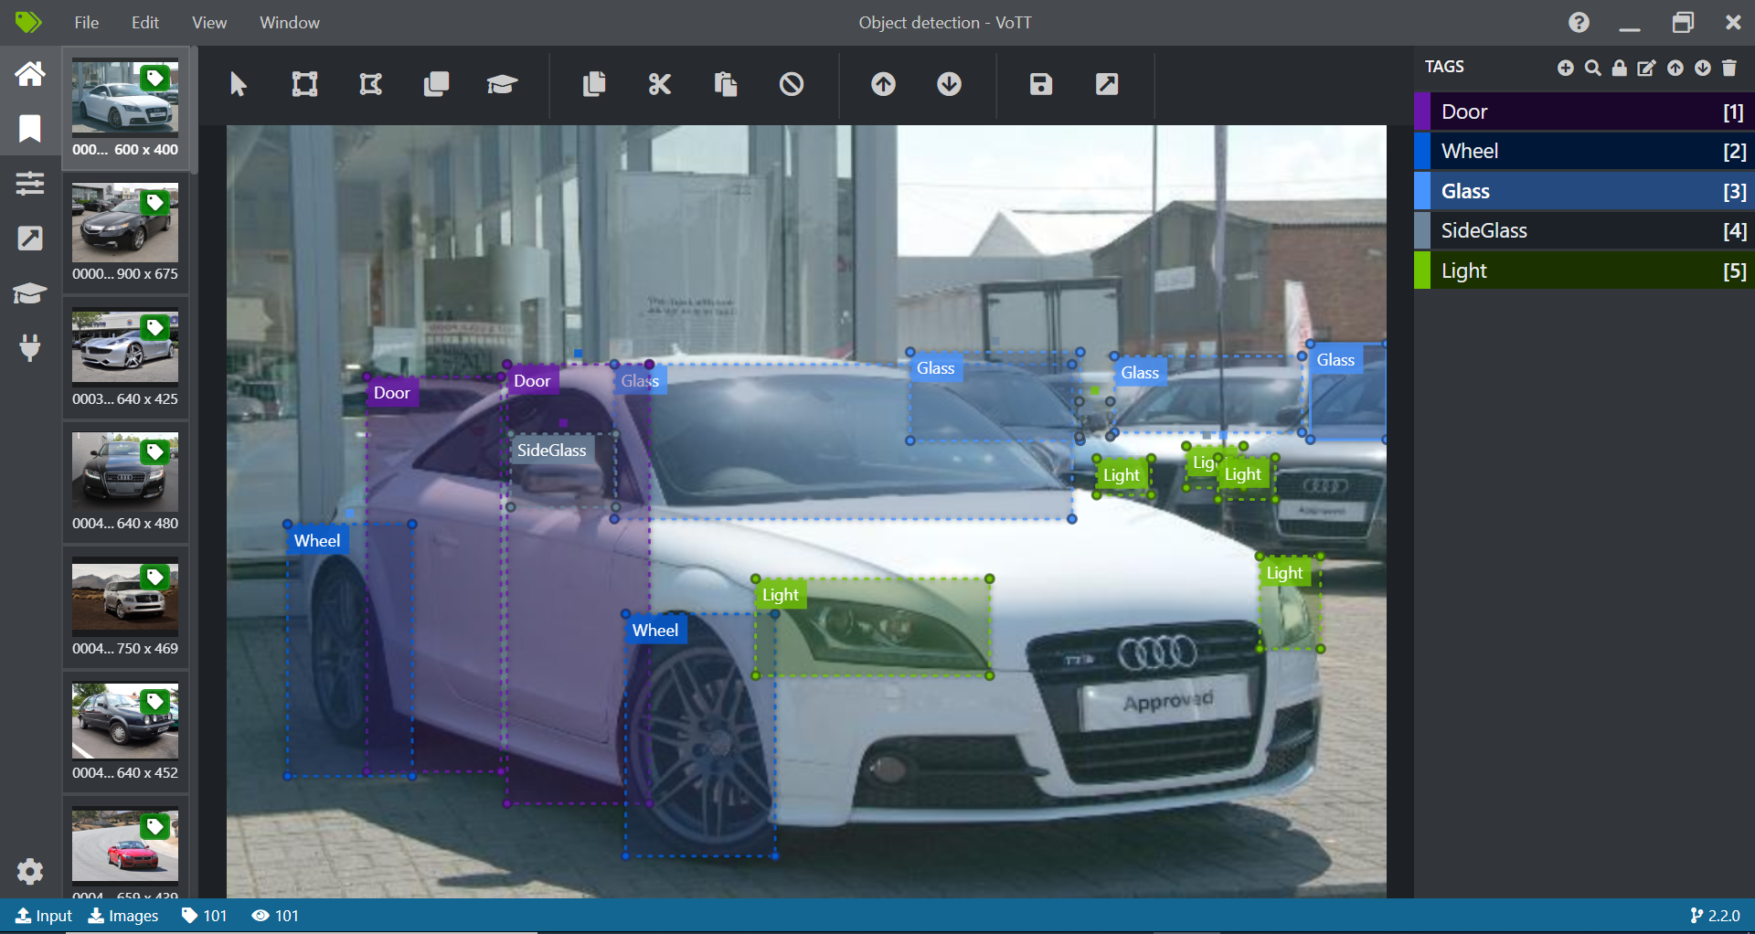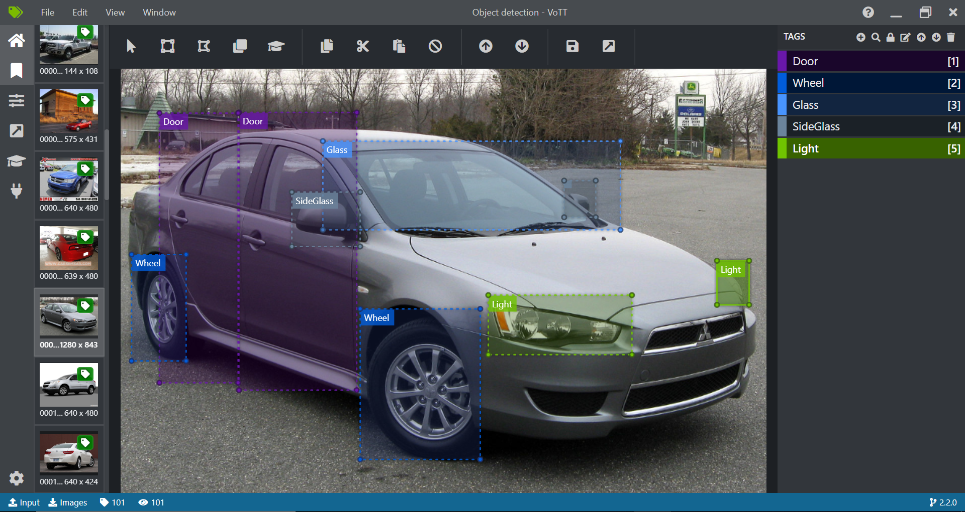

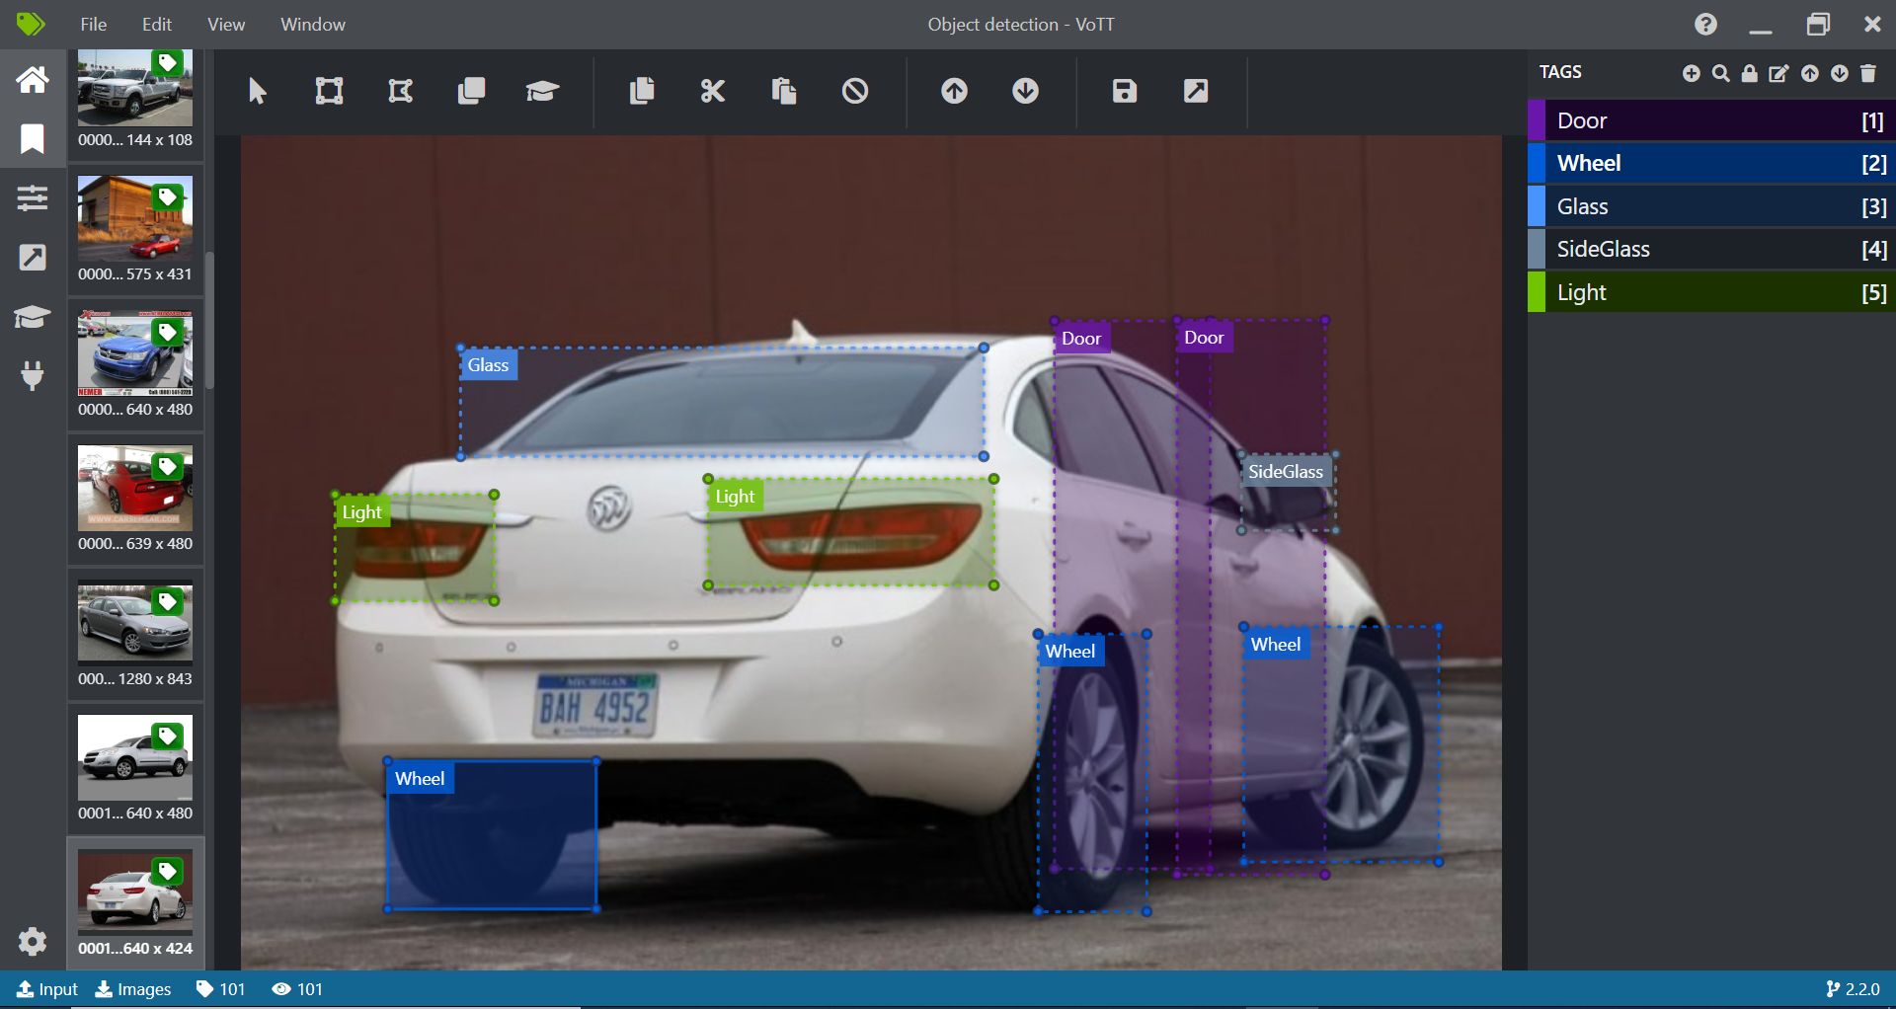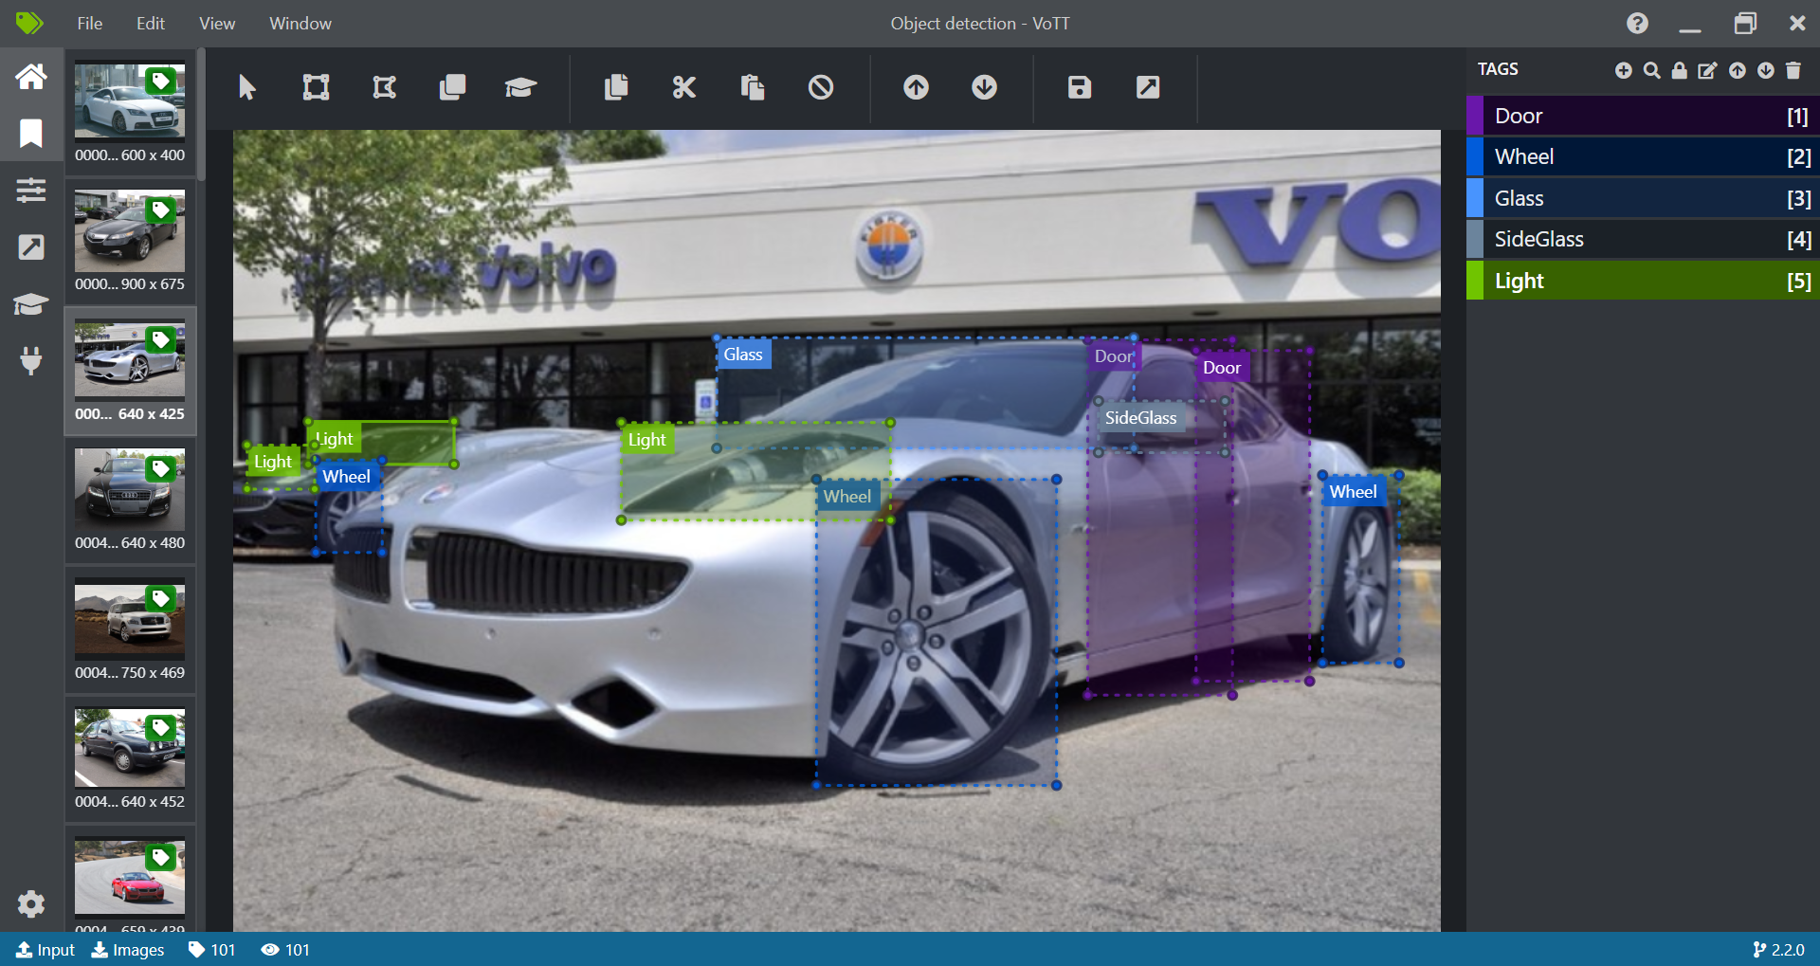

Fig 5: Annotation on Training Images using VoTT

Some of the results of Car Parts Detection using YOLOv3 on Testing Images are as follows:

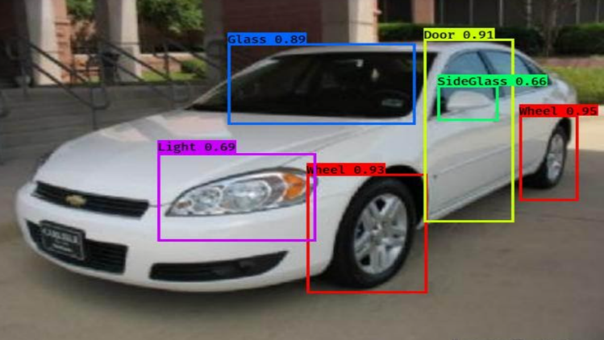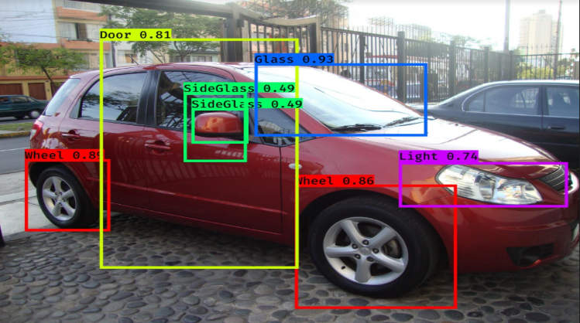

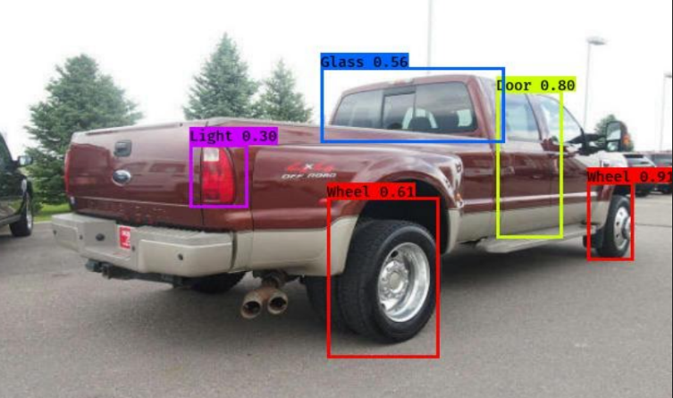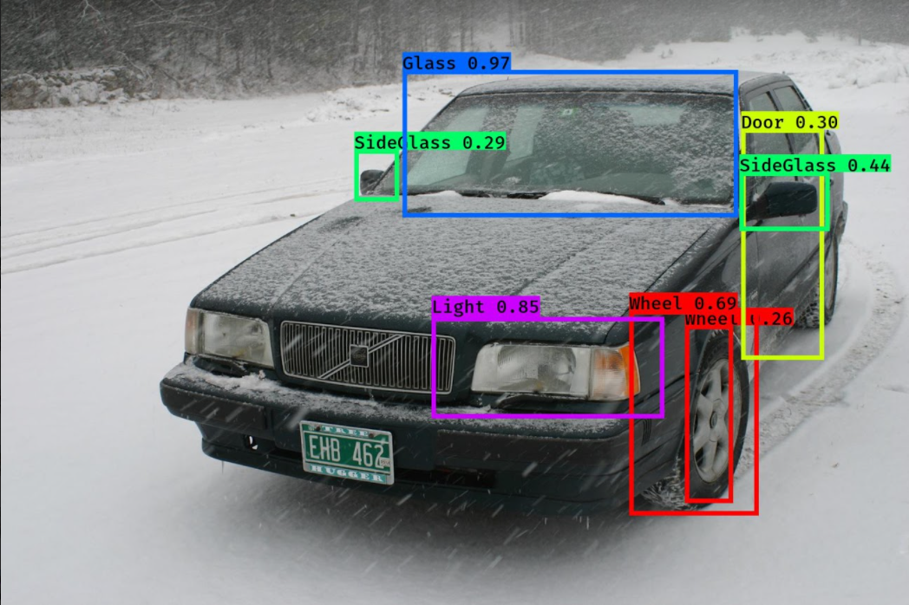

Fig 6: Car Parts Detection using Yolov3 on Testing Images

**Phase 2**: 2 Newly Captured Images added inside Training Images and Test Images folders.

Annotation results on Training Images using VoTT are as follows:

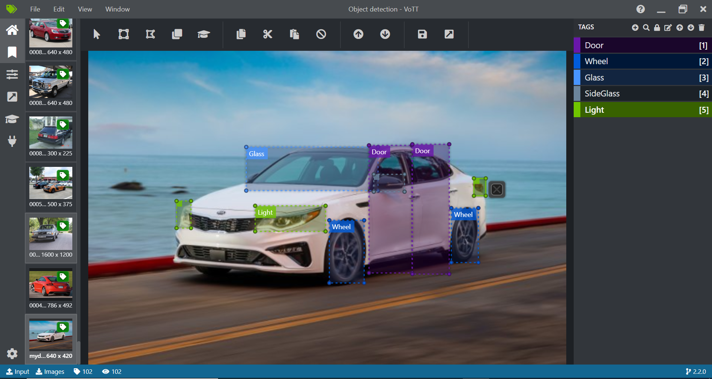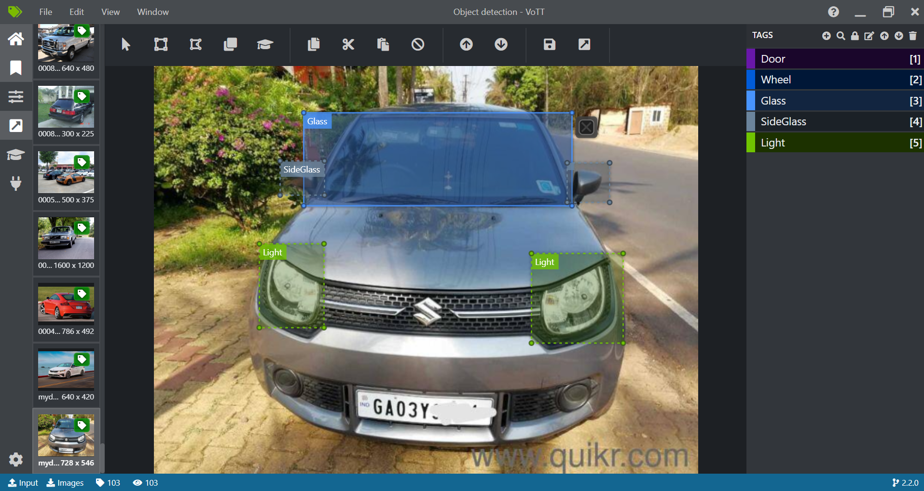

Fig 7: Annotation on newly captured Training Images using VoTT

Some of the results of Car Parts Detection using YOLOv3 on Testing Images are as follows:

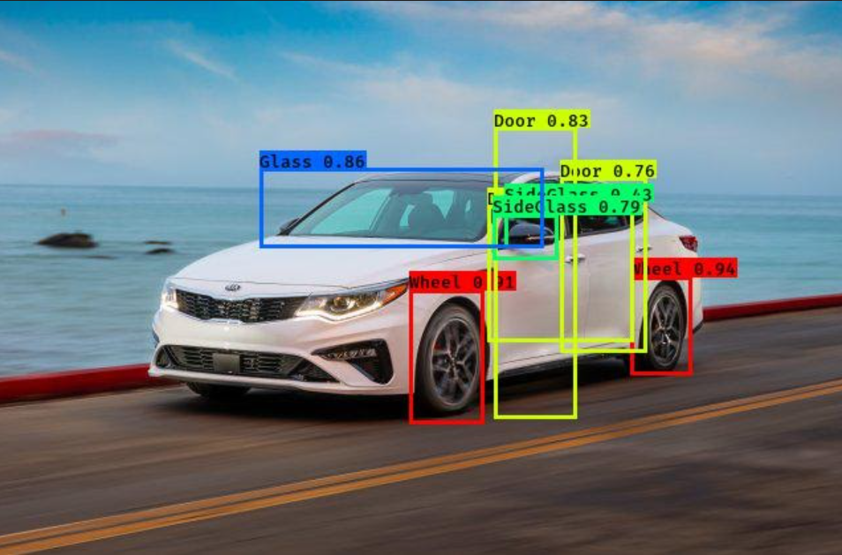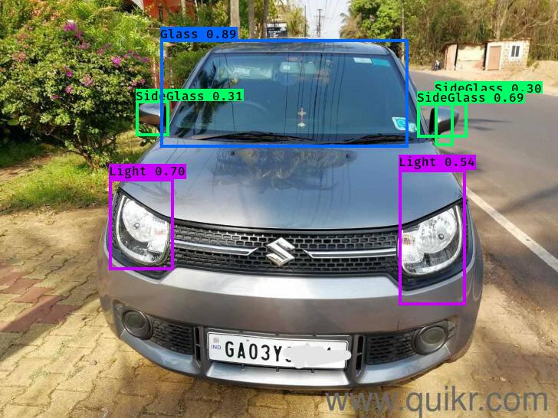

Fig 8: Car Parts Detection using Yolov3 on newly captured Testing Images

**Phase 3**: 10 Newly Captured were added inside the Test Images folder. Annotation and training of these images were not carried out.

Some of the results of Car Parts Detection using YOLOv3 on unseen Testing Images are as follows:

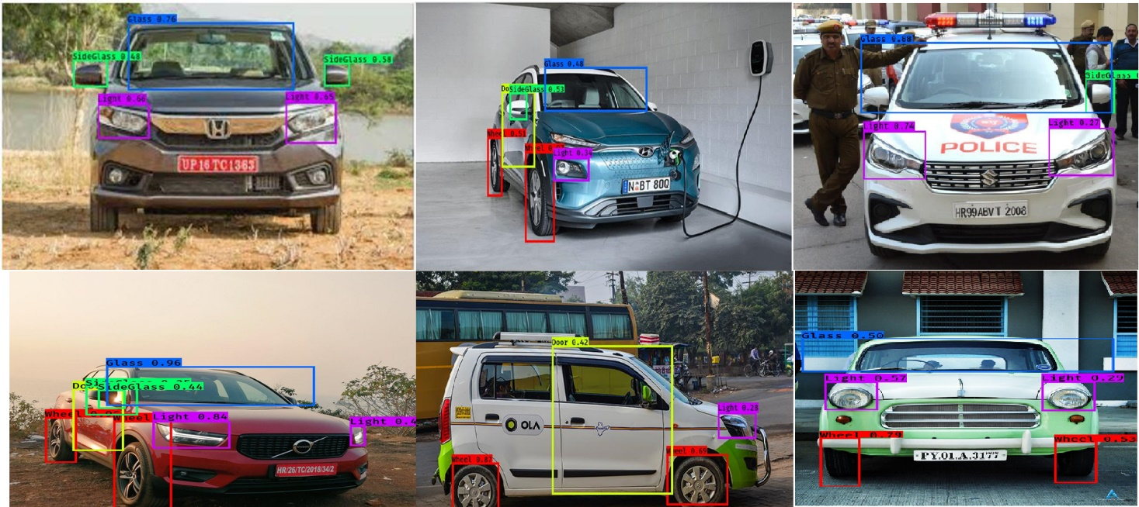

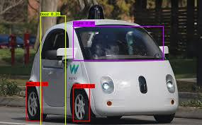 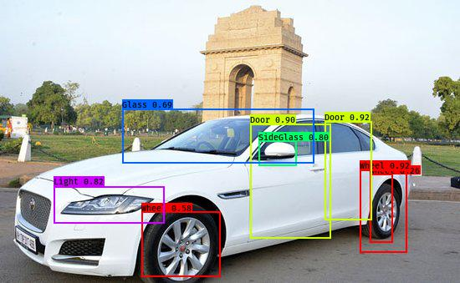 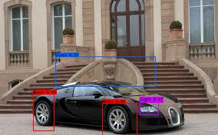 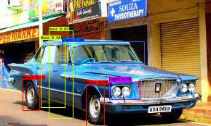

Fig 9: Car Parts Detection using Yolov3 on unseen Testing Images

The below table represents the average confidence score/IOU of each label in every phase of this project.

We also find the average predicted score for each phase.

|  |  |  |  |  |
| --- | --- | --- | --- | --- |
| Label Index | Label | Confidence Score in Phase1 | Confidence Score in Phase2 | Confidence Score in Phase3 |
| 0 | Light | 0.591444 | 0.618585 | 0.511663 |
| 1 | Glass | 0.745640 | 0.872962 | 0.716830 |
| 2 | Side Glass | 0.490936 | 0.506028 | 0.490544 |
| 3 | Door | 0.638261 | 0.667751 | 0.586294 |
| 4 | Wheel | 0.746288 | 0.925647 | 0.794101 |
|  | Average Confidence Score | 0.660311 | 0.669127 | 0.640702 |

Table 1: Average Confidence score in every phase

**Conclusion:** From the above results, we can conclude that the YOLOv3 model is much faster and accurate in terms of car parts detection and giving good prediction with the highest IOU score of 0.79 on the unseen data and 0.92 on the trained data.

**Future scope:** The YOLOv3 model which was implemented on car parts identification can also be used on other applications like car parts damage detection, car parts assembly etc. Also, we need to improve this model for parts identification of multiple cars in one image frame since it was not detecting some parts of more than one car in an image.

**References**:

1. Dataset: <https://github.com/bhadreshpsavani/CarPartsDetectionChallenge/tree/master/Data/Source_Images/Training_Images>

<https://github.com/bhadreshpsavani/CarPartsDetectionChallenge/tree/master/Data/Source_Images/Test_Images>

1. Reference Code:

<https://github.com/bhadreshpsavani/CarPartsDetectionChallenge/blob/master/TrainYourOwnYOLO.ipynb>

1. Information: <https://github.com/bhadreshpsavani/CarPartsDetectionChallenge/>

<https://pjreddie.com/darknet/yolo/>

<https://pjreddie.com/media/files/papers/YOLOv3.pdf>

<https://arxiv.org/pdf/1506.02640.pdf>

<https://www.pyimagesearch.com/2016/11/07/intersection-over-union-iou-for-object-detection/>